**Lab 1. Introduction to Raspberry Pi and Python**

**Objectives**

* Introduction to Raspberry Pi and Raspbian.
* Introducing the students to Python programming.
* Using the IDLE (IDE) to program python applications.

**Equipment and Tools**

* Monitor
* HDMI to VGA converter
* IDLE IDE
* Raspberry Pi 3 with Raspbian Installed
* Micro usb cable

**What is Raspberry Pi?**

Raspberry Pi is a

* low cost, credit-card sized computer
* device capable of doing everything a desktop computer can do
* device that has the functionality of both a computer and a micro-controller

Rasberry Pi has been used in a wide array of digital maker projects, from music machines and parent detectors to weather stations and tweeting birdhouses with infra-red cameras [1]. In this course we use Raspberry PI 3 as it comes with built-in WiFi and Bluetooth module.

**Technical Specification[2]**:

* 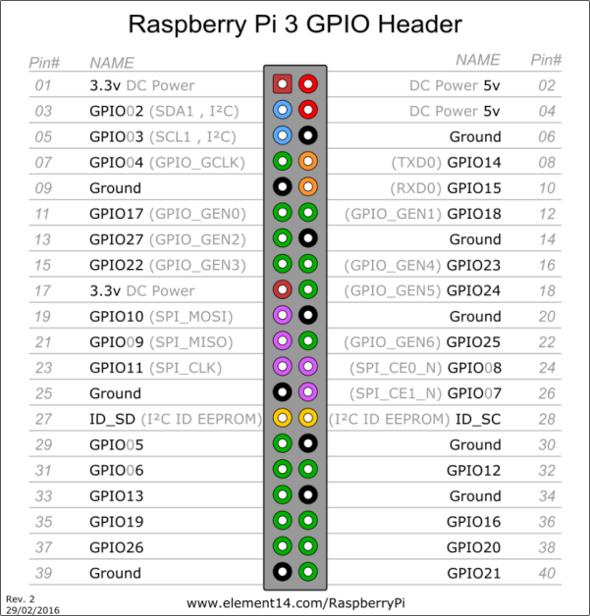Broadcom BCM2837 64bit ARMv7 Quad Core Processor powered Single Board Computer running at

Figure 1. Raspberry pi 3 PIN out

* 1.2GHz, 1GB RAM
* BCM43143 WiFi on board
* 40pin extended GPIO
* Bluetooth Low Energy (BLE) on board
* 4 x USB 2 ports
* 4 pole Stereo output and Composite video port
* Full size HDMI
* CSI camera port for connecting the Raspberry Pi camera
* DSI display port for connecting the Raspberry Pi touch screen display
* Micro SD port for loading your operating system and storing data
* Upgraded switched Micro USB power source (now supports up to 2.4 Amps)
* Expected to have the same form factor has the Pi 2 Model B, however the LEDs will change position.

Figure 2 shows the Raspberry Pi 3 Model B board.

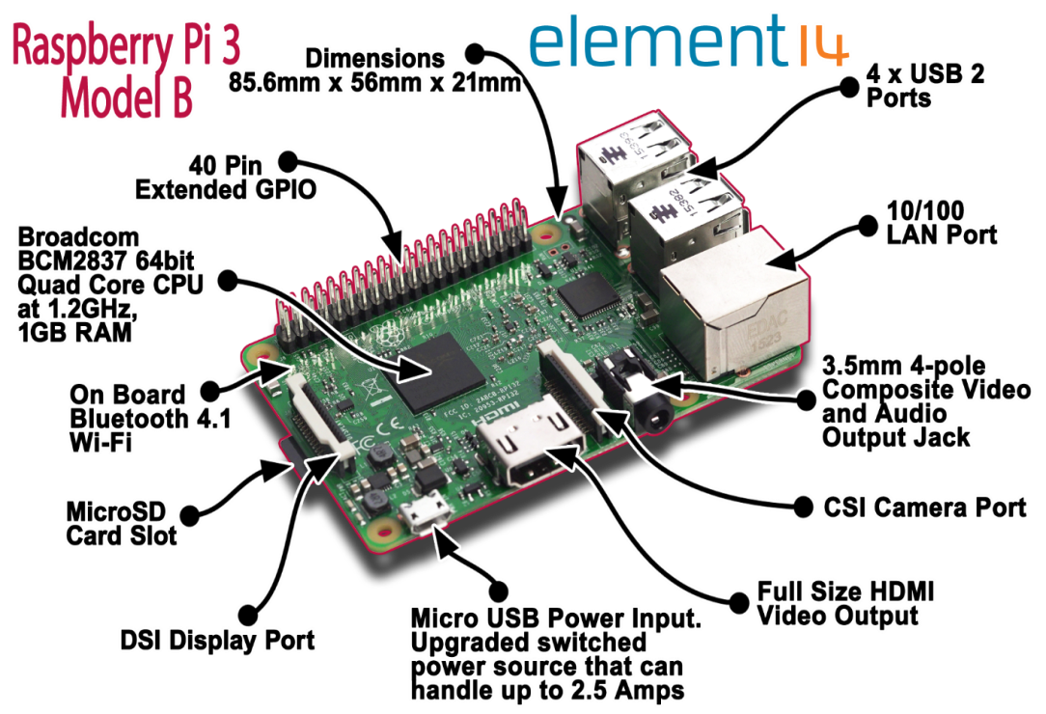

Figure 2 Raspberry Pi 3 [3] Board layout.

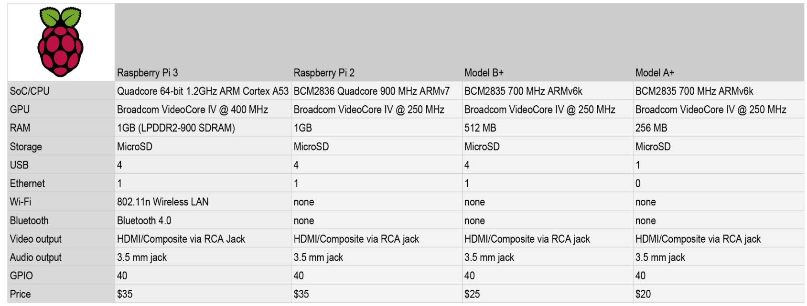

Figure 3 Board Feature Comparison [4]

**Operating System in Raspberry Pi**

Raspberry Pi has support for multiple operating system. However, Raspbian is the official supported Operating System. Raspberry Pi usually comes with no 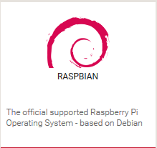operating system pre-installed. Thus, we have to install an operating system to use Raspberry Pi. We choose Raspbian OS as it is officially supported and has a big community of users.

Steps to install Raspbian:

* 1. Download latest image from

<https://www.raspberrypi.org/downloads/raspbian/>

* 1. Create a bootable SD card from the image
  2. Insert the SD card in Raspberry Pi and power on Raspberry Pi
  3. Go through the installation procedures
  4. Wait for around 10-20 mins to complete the installation
  5. Once installation is completed, you can boot into Raspbian OS

For more information visit:

<https://www.raspberrypi.org/documentation/installation/installing-images/>

**C:\Users\b00042500\Downloads\coneect_setup.png**

Figure 4. Connection Diagram

**Programming in Raspberry Pi**

Multiple languages can be used to program in Raspberry Pi. Python, C, C++, Java, Scratch, and Ruby all come installed by default on the Raspberry Pi. Python is the official programming language of the Raspberry Pi and IDLE 3, a Python Integrated Development Environment [5].

This lab focuses on developing micro-controller solutions using Python in Raspberry Pi.

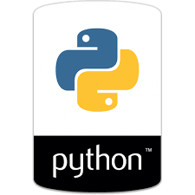**Python**

Python is an interpreted, object-oriented, high-level programming language with dynamic semantics [6]. Python is simple and easy to learn. Python has no compilation step and the edit-test-debug cycle is incredibly fast. Python is used domains ranging from Desktop application development to scientific and numeric computing [7].

**Python Syntax**

* There are no datatype for variables, however, one can parse the variable to be of a particular data type.

Example:

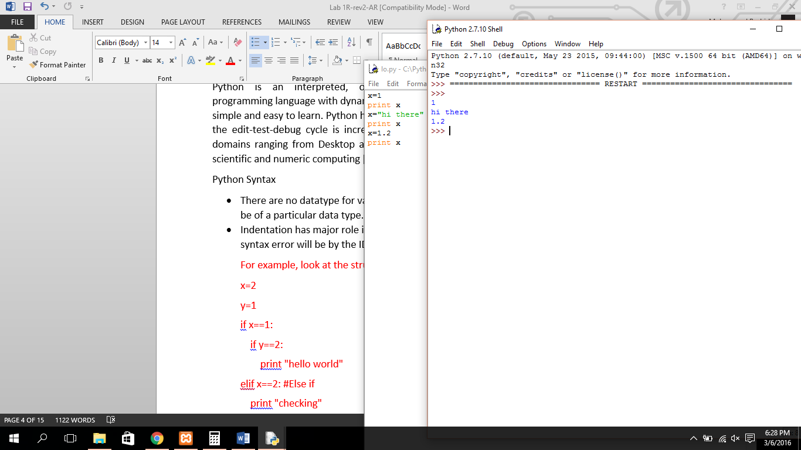

* Indentation has major role in python. If code is not properly intended, syntax error will be by the IDE.

Example:

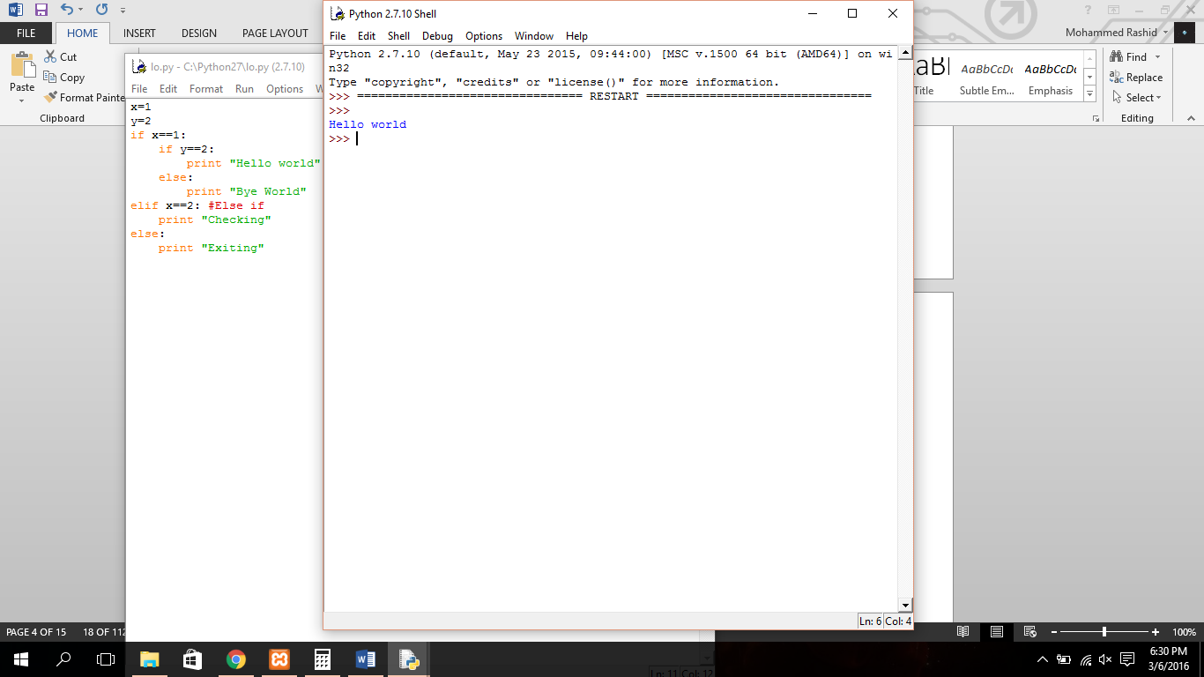

* There are no semicolons at the end of a statement.
* Functions names have to be preceded with def instead data types.

Example:

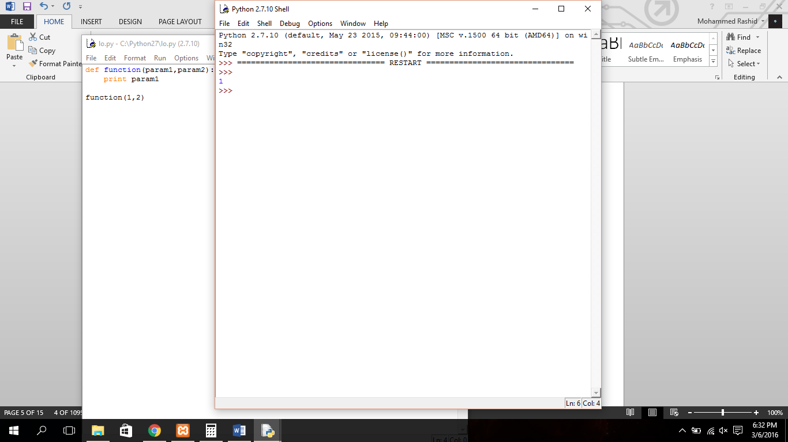

* Code block is starts with :[colon] and everything inside that block has to be intended by a tab space.

Example:

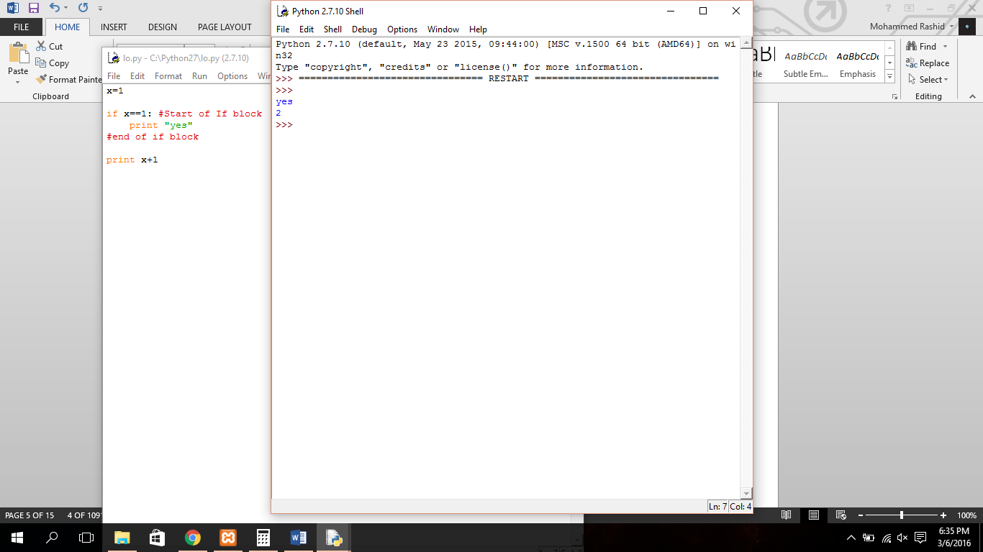

* For single line comments use #
* Multiline comments should be within ‘’’[Three apostrophes] and ‘’’ [Three apostrophes] block.

Example:

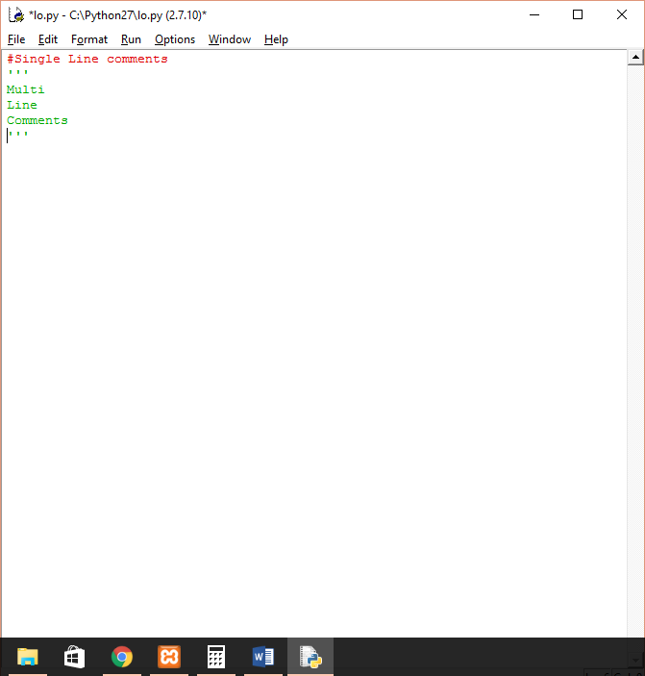

* Looping in Python
  + While Loop:

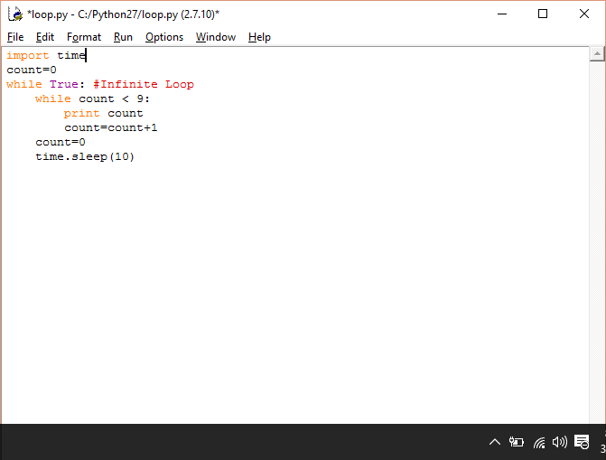 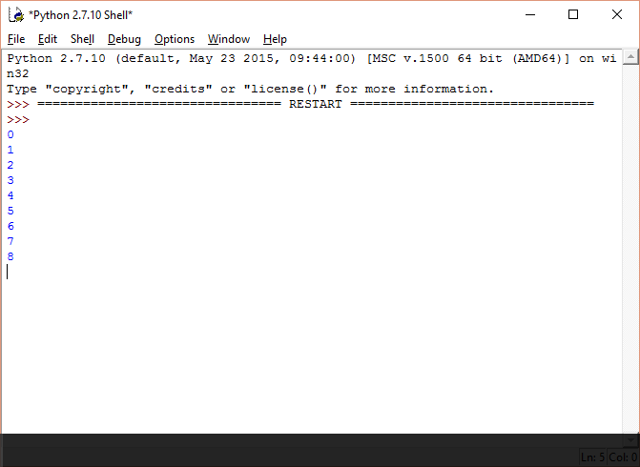

* + For Loop:

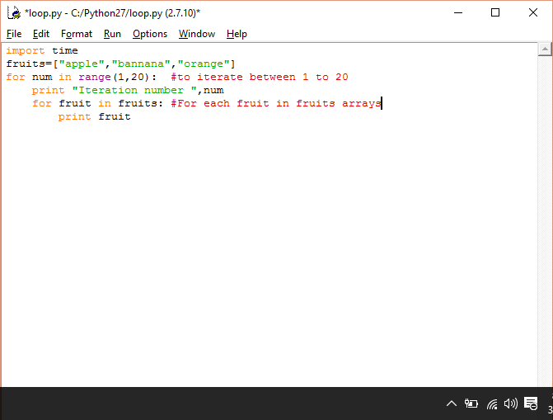

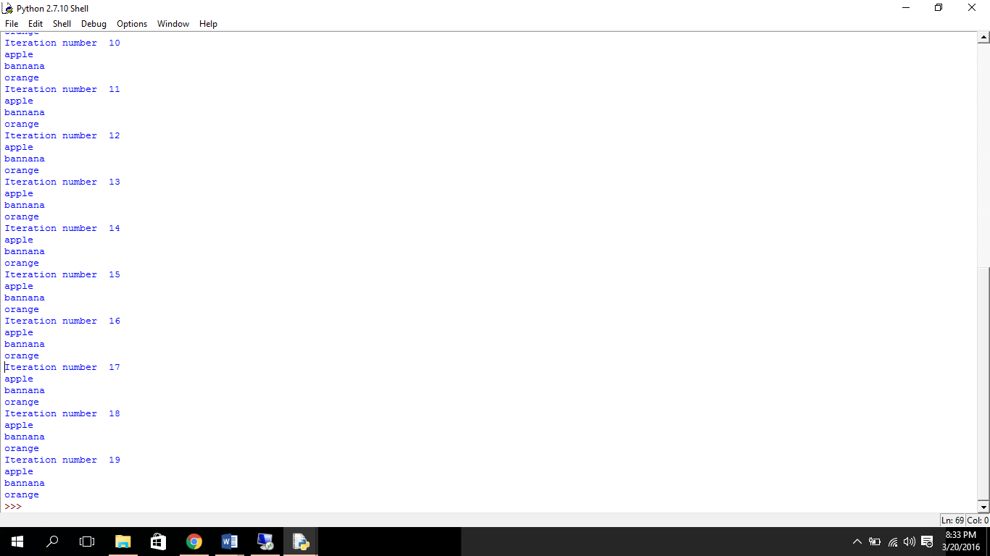

* + Continue and Break

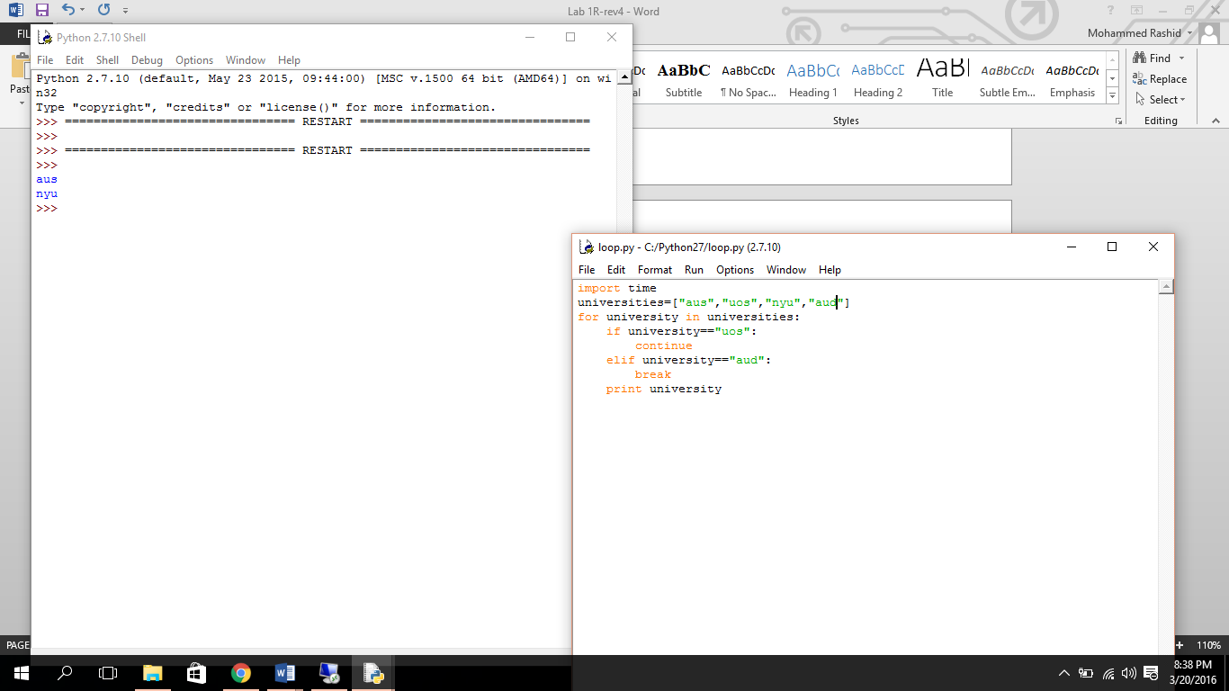 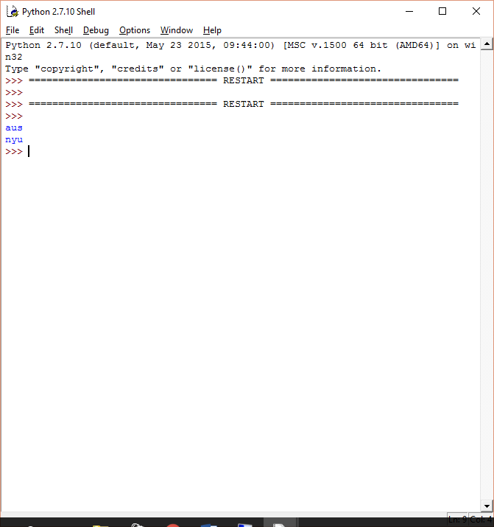

**Python Programming in Raspberry Pi**

We use IDLE (Integrated Development and Learning Environment) to program python applications.

**Steps to create .py file**

* Open IDLE

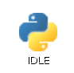

* Click on File>New File

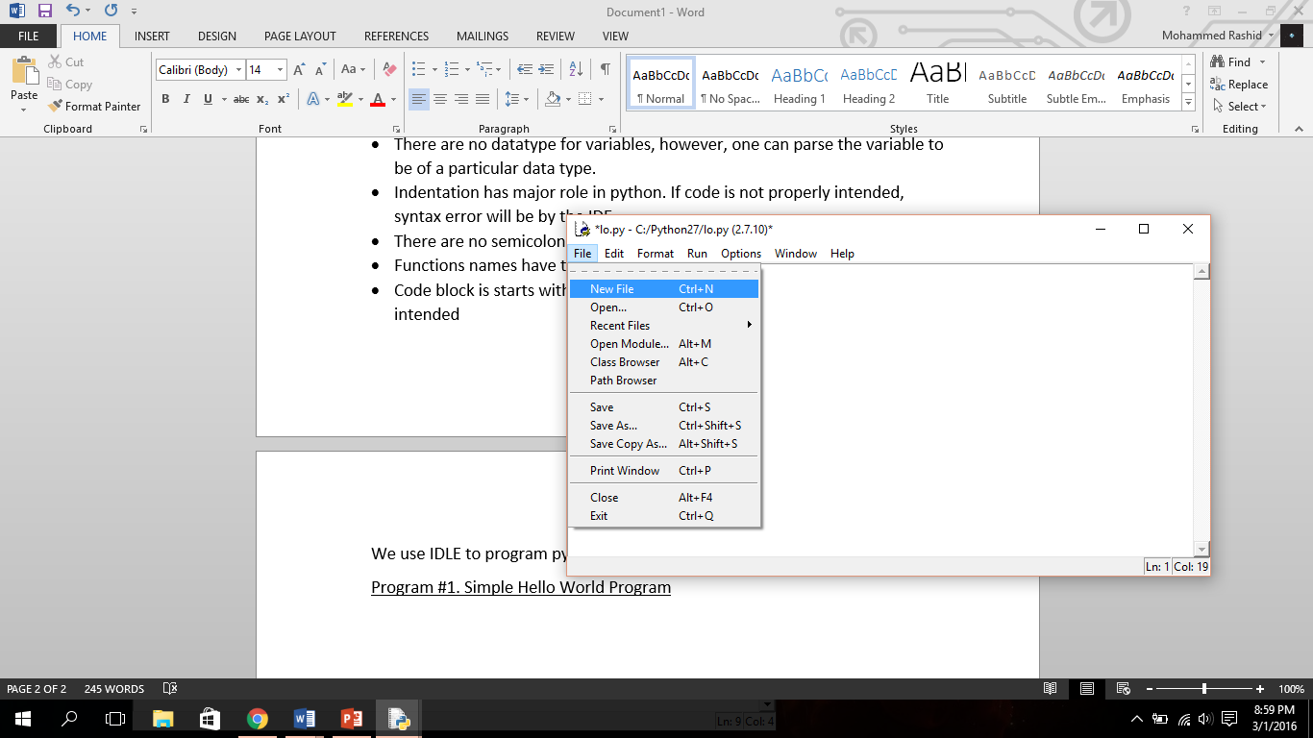

* After clicking New File, an untitled window will be opened.

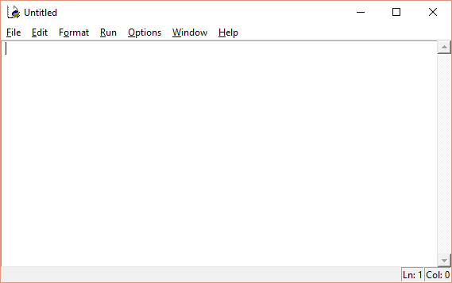

* Go to Files>Save As…

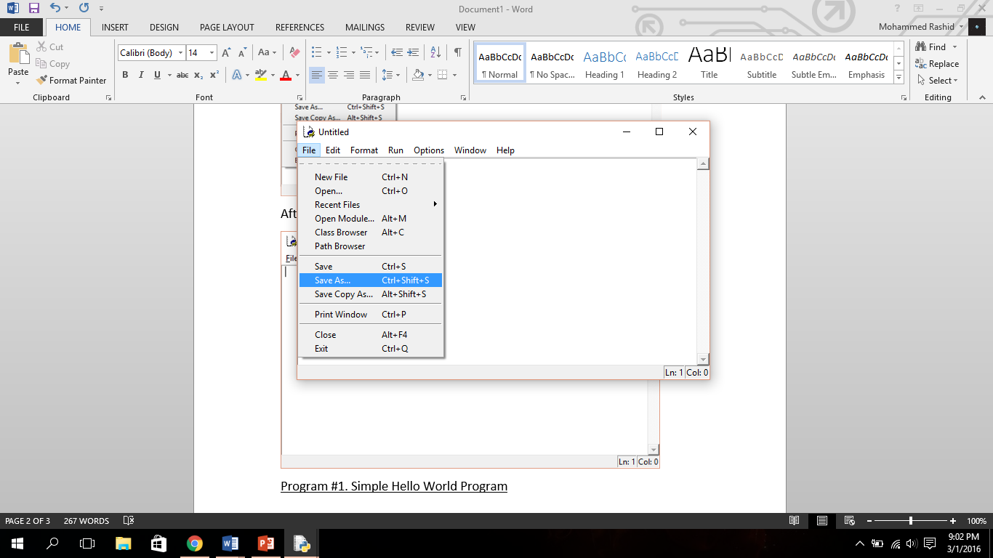

* Save the program in your home directory with the name of your choice

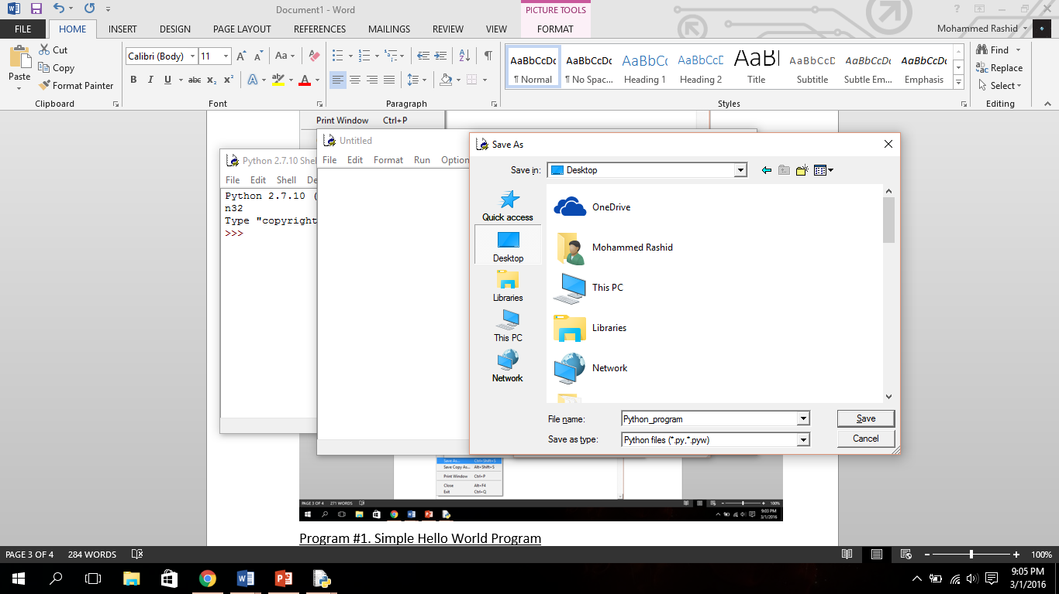

* Now you have a .py file. To run program go to Run>Run Module

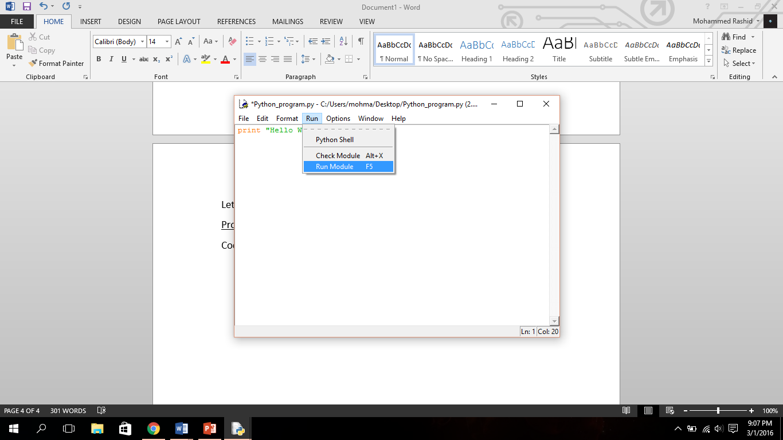

Now that we are familiar working with IDLE, let us make some programs using python.

**Exercises**

Program #1. Simple Hello World Program

Write a program to print “Hello World!” in python.

Hint: use print “string to print”

Code:

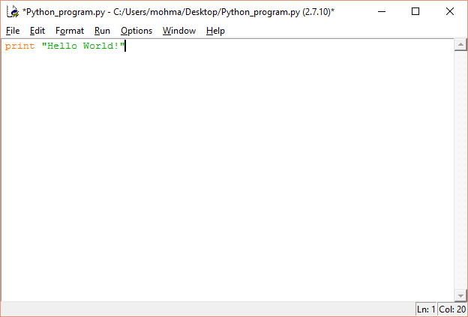

Result:

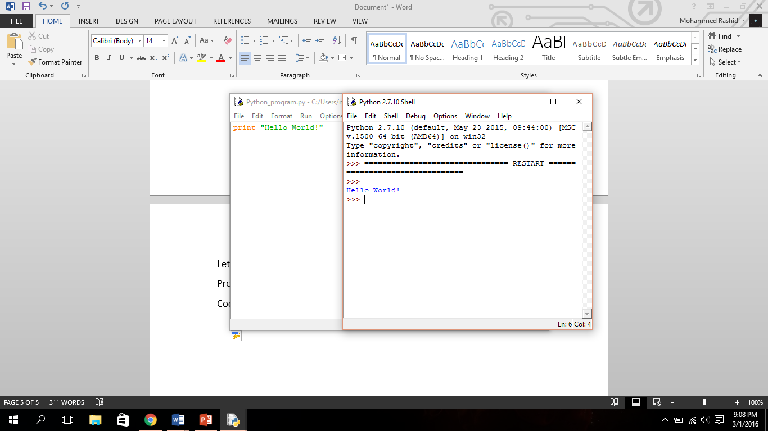

Program #2. Basic Input

Write a program that prompts the user to enter an input and prints the entered input back to the user.

Hint: Use raw\_input(‘string to be displayed to user’) to prompt users to enter an input

Code:

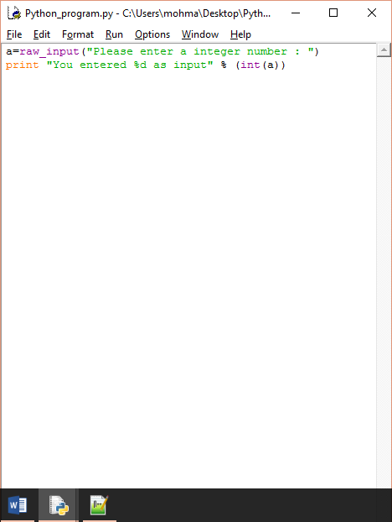

Result:

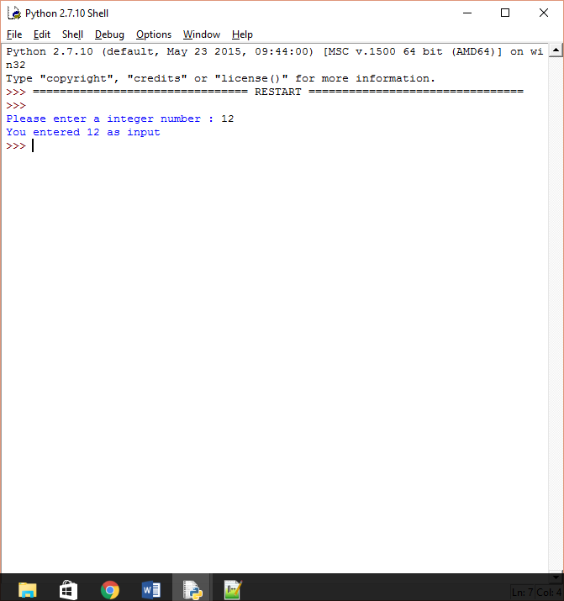

Program #3. Addition Function

Write a function that takes two integers as parameters and returns the same as result.

Code:

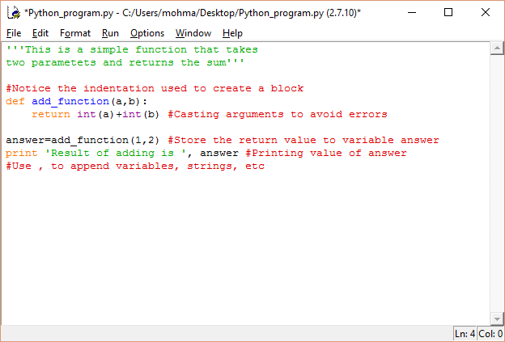

Result:

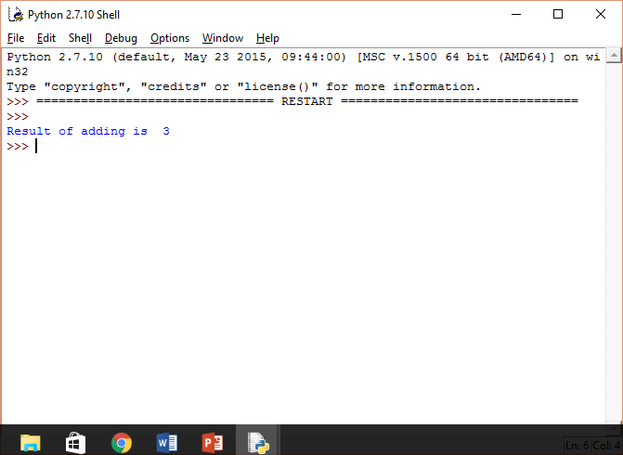

Program #4. Palindrome Checker

Write a function in python that check if an entered string is a palindrome or not.

Hint: use string[::-1] to print string in reverse order.

Code:

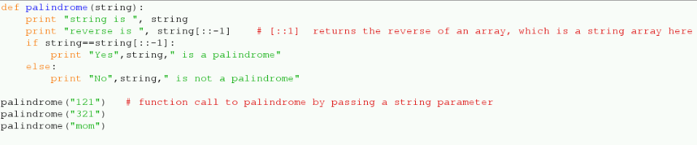

Result:

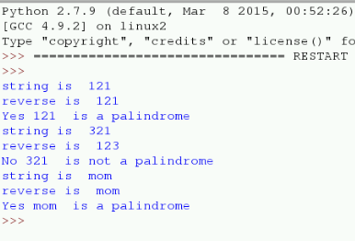

Program #5. Swap function

Write a function in python that swaps the value of two integer passed to it and prints the values before and after swapping.

Hint: use a,b=b,a to achieve

temp=a;

a=b;

b=temp;

Code:

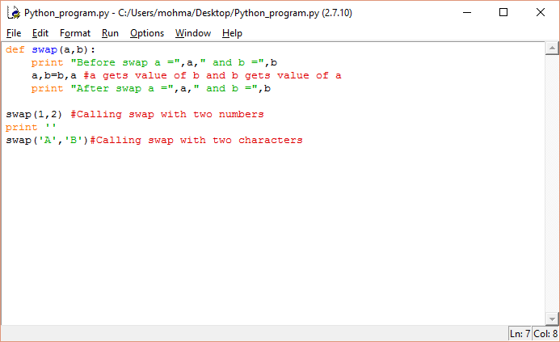

Result:

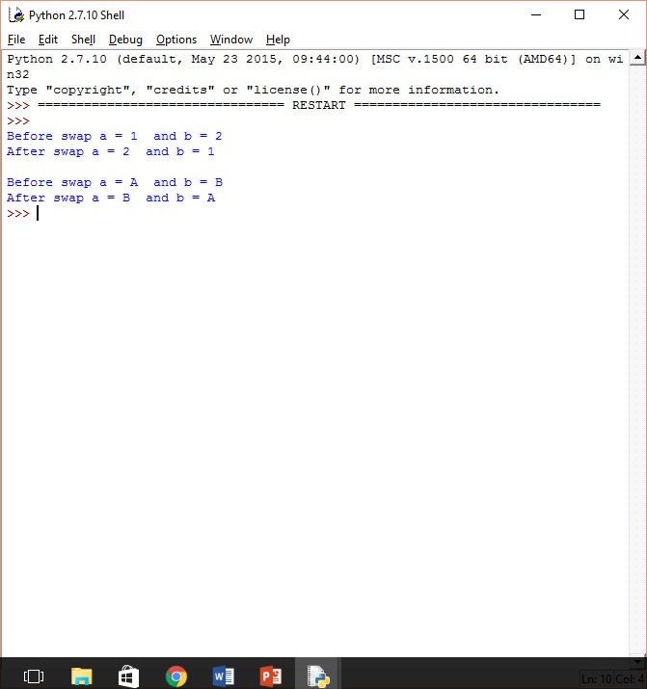

Program #6. Introduction to import

Write a function in python that makes use of cosine function offered by math library and prints value of cosine of passed parameter.

Hint:

Import math library in python by writing “import math”. Once imported, functionalities of offered by this library can be called. For instance, to get sin of a number use math.sin(number)

Some math library function and constants:

math.pi: The mathematical constant π

math.cos(x): Return the cosine of x radians

math.fabs(x): Return the absolute value of x.

math.pow(x, y): Return x raised to the power y.

math.sqrt(x): Return the square root of x.

For more functions visit: <https://docs.python.org/2/library/math.html>

Code:

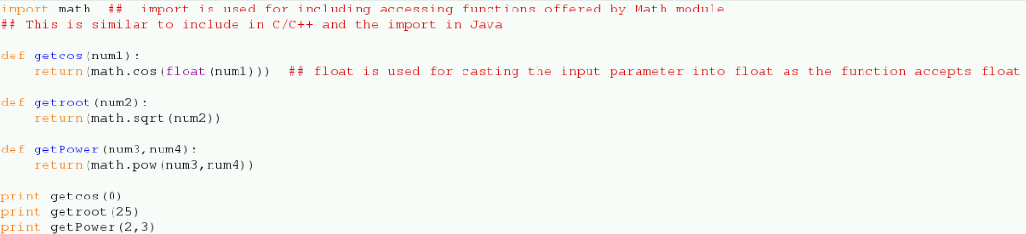

Result:

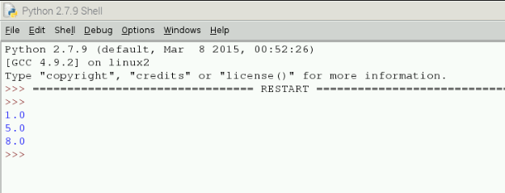

Program #7. Error handling

Write a function add() in python that takes two parameters a,b and returns the sum. The passed variables must be casted to float before adding and returning the result.

Once complete enter two characters as a,b [like add('a','b')]. It causes an exception. To cover situations like this we use try-catch or try-expect block.

Hint:

The code susceptible to cause exception must be put in try block

When code inside try block causes an exception

The program will try to find the except block that handle the type of error thrown by the code in try block.

Code:

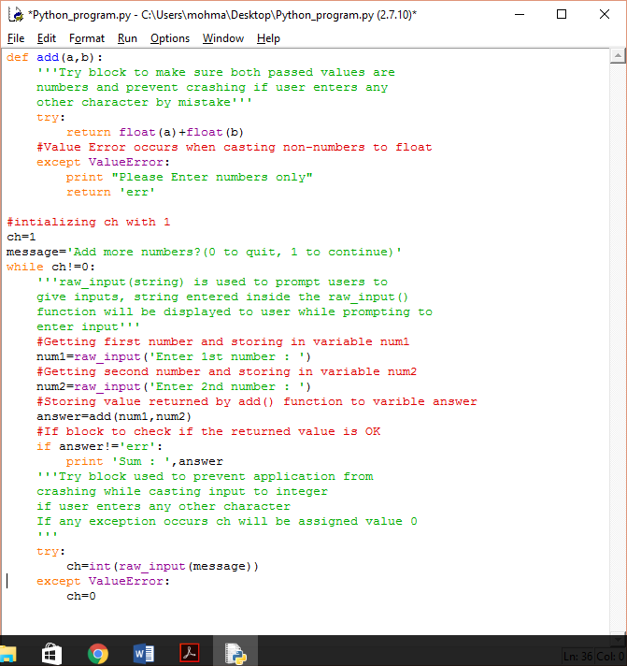

Result:

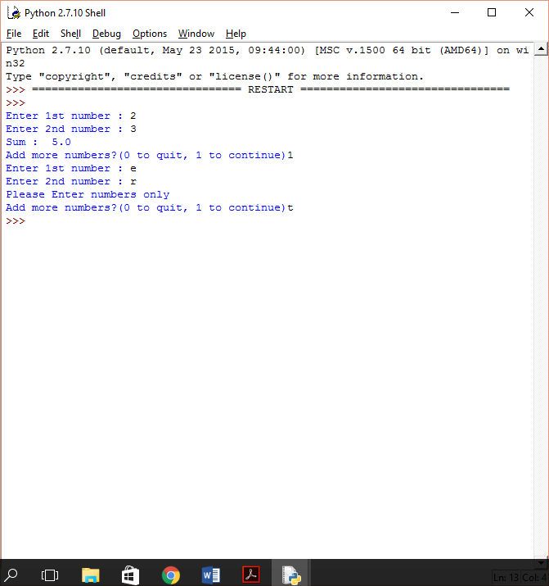

**References**

[1] <https://www.raspberrypi.org/help/what-is-a-raspberry-pi/>

[2]<http://www.farnell.com/datasheets/2020826.pdf>

[3]<https://www.element14.com/community/servlet/JiveServlet/showImage/102-80899-11-252356/Pi3+Breakout+Feb+29+2016.png>

[4] [http://lifehacker.com/the-raspberry-pi-3-adds-built-in-wi-fi- and-bluetooth-g-1761317416](http://lifehacker.com/the-raspberry-pi-3-adds-built-in-wi-fi-%20and-bluetooth-g-1761317416)

[5] <http://www.engadget.com/2012/09/04/raspberry-pi-getting-started-guide-how-to/>

[6] <https://www.python.org/doc/essays/blurb/>

[7] <https://www.python.org/about/apps/>